Kelsey Langland
VA SOL - STANDARD 8.4 (READING)
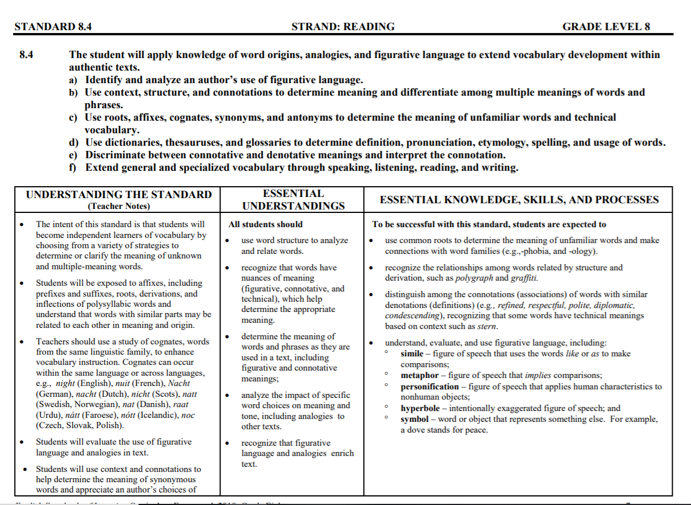
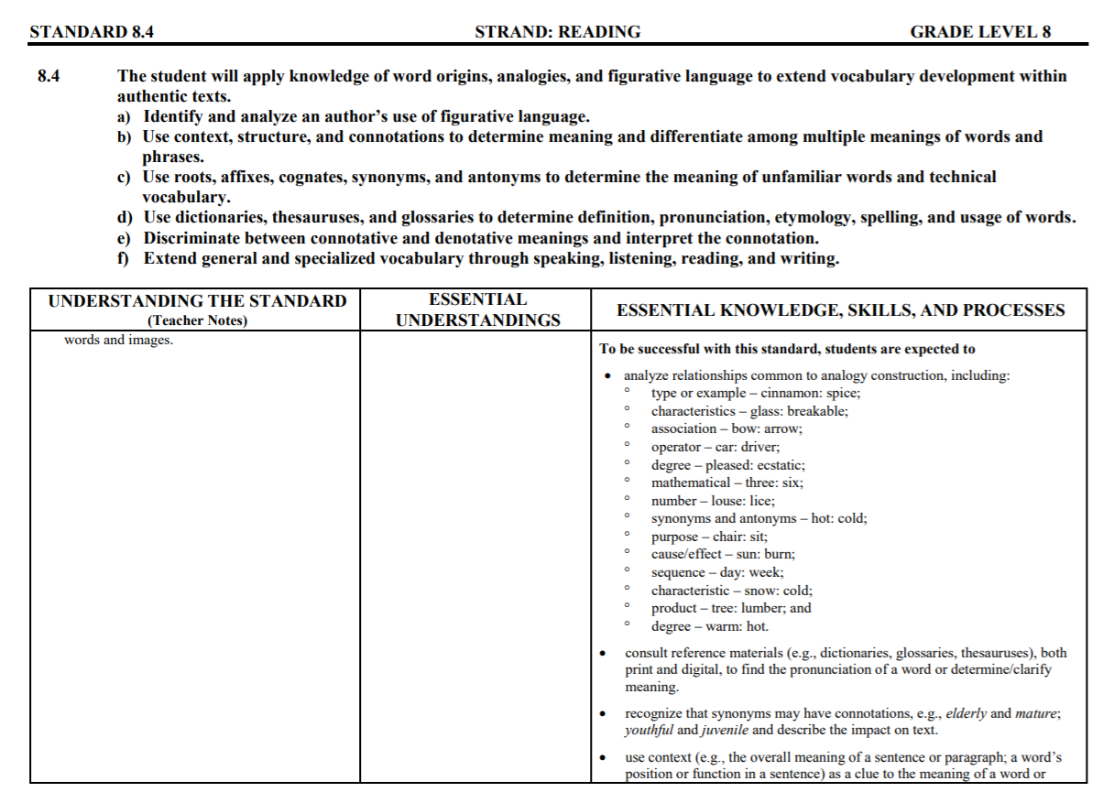
Kahoot - Kahoot is a fun, interactive web-based application that helps engage students in lessons. This application is an exciting way to create and share content with students through the utilization of a game. Students can work in groups or on their own with this application. Kahoot allows for scoring and time limits that encourage healthy competition amongst students. Kahoot is universal, so you teachers can create a game for any and all subjects and topics. Kahoot also allows teachers to utilize games that other users already created.

Kahoot can be used as a way to review material leading up to SOLs or other exams. Alessandra King (2017), for instance, uses Kahoot “as formative assessment, to practice skills and increase their retention, and especially to review before quizzes and tests” (p. 36). SOL season can be a stressful time for both students and teachers. They feel the pressure from their schools to achieve high scores for their class. Through the use of Kahoot, teachers can review over information from the semester or school year. Kahoot can encourage students to get more engaged at the end of the year.

Nearpod - Nearpod allows teachers to share presentations with students in an engaging and interactive manner. This application allows students to either work at the pace of the class or at their own pace. The pin for a Nearpod presentation can be shared in an email, on a social media platform, by link, and/or on Google Classroom. Student answers to each interactive activity can be viewed as the class progresses through the lesson. Additionally, student answers can be shared with the class. Through the usage of Nearpod, teachers can share multimedia with their classes.

Nearpod can be used for subjects that require more writing or work, like Math or English. Students can solve Math equations, and their teachers can see where they went wrong on problems. On the contrary, teachers can display correct answers to the class and possible show the class a new way to explain a problem, with the student’s work. For English, students can practice parallel structure and writing. Nearpod allows teachers to compare and contrast student answers. Furthermore, as Perez (2017) points out, the utilization of Nearpod can “boost student engagement, promote collaborative experiences, assess student comprehension, and allow the freedom to create active classroom alternatives to the lecture-only format of yesteryear” (p. 108). In essence, Nearpod is an application that can help engage more students in classroom activities than the tradition style of teaching.

Plickers - With Plickers, teachers can create different folders for their presentations. Plickers allows teachers to assign different cards to each student. This is beneficial for classes that do not have access to technology for every student. However, cards must be printed for the class. Furthermore, teachers can look at reports to view how students do as individuals or on individual questions. Teachers utilize their phones to scan student cards like a QR code to receive their answers to each question. Different questions can be assigned to each class.

Plickers can be utilized in place of some examinations. This can help to save money on paper and pencils because teachers can reuse cards. Furthermore, teachers can offer incentives and reward students who perform well. This is a fun, interactive way to engage students in classes more. Not only is it fun and interactive, but Plickers is a simple tool that allows teachers to compare student answers and scores. Smith and Mader (2015) emphasize that Plickers can “provide the data teachers need to monitor and adjust their teaching according to current student knowledge” (p. 10). By utilizing Plickers, teachers can have easy access to see what material they need to reteach or re-explain.

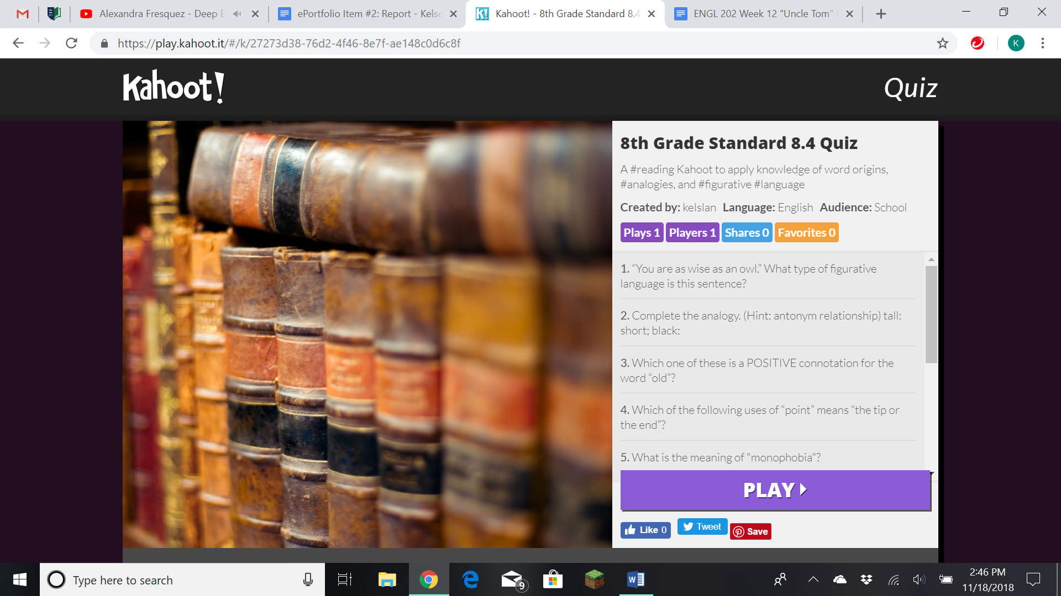
Kahoot Link: https://play.kahoot.it/#/k/27273d38-76d2-4f46-8e7f-ae148c0d6c8f
Questions & Answers:
- “You are as wise as an owl.” What type of figurative language is this sentence?
  - metaphor
  - simile
  - personification
  - hyperbole
- Complete the analogy. (Hint: antonym relationship) tall: short; black:
  - cat
  - orange
  - white
  - short
- Which one of these is a POSITIVE connotation for the word “old”?
  - elderly
  - ancient
  - decrepit
  - stale
- Which of the following uses of “point” means “the tip or the end”?
  - None of them
  - It is rude for you to point at other people.
  - Susan, you make a good point.
  - The pencil’s point is extremely sharp.
- If we know that “mono-” means “one, only, single” and “-phobia” means “fear of”, what is the meaning of “monophobia”?
  - The fear of numbers
  - The fear of being alone
  - The fear of people
  - The fear of water
- Which one of these is a NEGATIVE connotation for the word “skinny”?
  - thin
  - scrawny
  - slim
  - slender
- Complete the analogy. (Hint: purpose relationship) pencil: write; book:
  - paper
  - throw
  - tear
  - read
- “I haven’t seen you in a million years.” What type of figurative language is this sentence?
  - hyperbole
  - symbol
  - simile
  - metaphor
- Which of the following uses of “bark” means “the sound a dog makes”?
  - They removed the bark from the tree.
  - Yogi likes to scratch his back on the bark.
  - My dog, Lucky, likes to bark at the mailman.
  - None of them
- If we know that “-ology” means “the study of”, what is “bacteriology” most likely the study of?
  - The study of bacteria
  - The study of climate
  - The study of organs
  - The study of backs

Synopsis:
As a future educator, I plan to utilize Kahoot for a variety of lessons. Specifically, for the Virginia Department of Education’s (2010) VA SOL Standard 8.4 in Reading, I would incorporate a Kahoot quiz in a lesson (p. 7-9). Asking a series of questions, I would like to use Kahoot to test my students’ knowledge of word origins, analogies, and figurative language (Virginia Department of Education, 2010, p. 7-9). This quiz is a fun way to engage my students and test to see which questions and topics I would need to reteach or rediscuss.

This experience would be rewarding because I could get more students involved in the lesson and test the class’ knowledge and understanding as a whole. On the contrary, it would be challenging for me to cover all subject matters under this standard. However, I could utilize other applications like Nearpod and Plickers to teach any additional material. In the future, I might try to create multiple different testing options. Overall, utilizing other applications alongside Kahoot would help my class to better learn the material.

References
King, A. (2017). Using Kahoot! Australian Mathematics Teacher, 73, 35-36. Retrieved from
http://eres.regent.edu:2048/login?url=http://search.ebscohost.com/login.aspx?direct=true
&db=a9h&AN=126785665&site=ehost-live
Perez, J. E. (2017). Nearpod. Journal of the Medical Library Association, 105, 108-10.
doi:10.5195/jmla.2017.121
Smith, B., & Mader, J. (2015). Formative assessment with online tools. Science Teacher, 82, 10.
Retrieved from http://eres.regent.edu:2048/login?url=http://search.ebscohost.com/login.
aspx?direct=true&db=a9h&AN=101822365&site=ehost-live
Virginia Department of Education. (2010). English standards of learning: curriculum framework
2010. Board of Education: Commonwealth of Virginia, 1-26. Retrieved from http://www.
doe.virginia.gov/testing/sol/frameworks/english_framewks/2010/framework_english_6-
8.pdf

